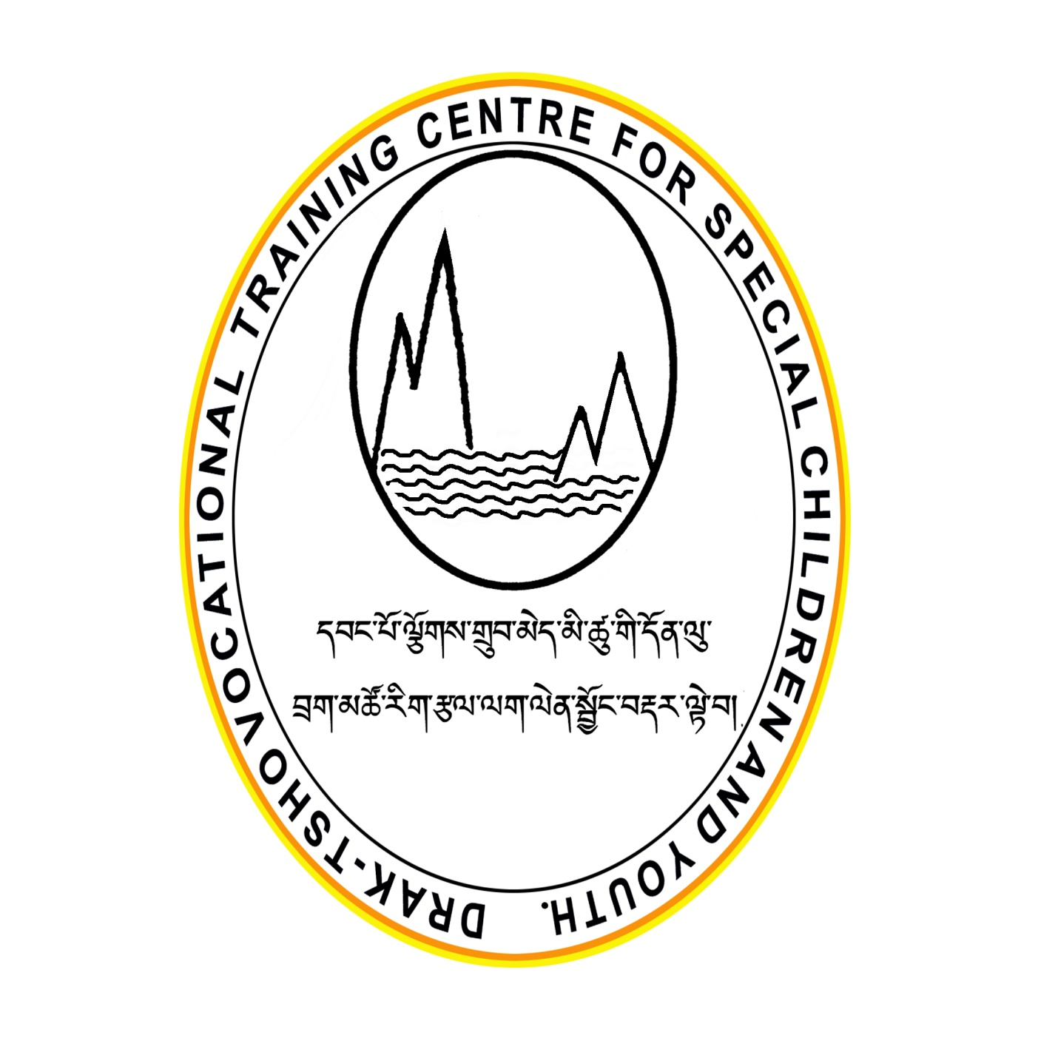

**ANNUAL REPORT 2013**

**Table of Contents**

**Foreword** 3

***“Making Bhutan Accessible”*** 4

***“Big Brother Big Sister”*** 4

**Family Health Forum:** 5

**Eunice Kennedy Shriver Day (EKS)** 6

**3rd December, the International Day of Persons with Disabilities:** 7

**Ability show at the YDF hall:** 8

**2nd October foundation day celebration:** 9

**Draktsho East:** 10

**Immediate Future Plans:** 11

**Acknowledgement:** 12

**Receipt and of Draktsho for the year ending 31st Dec, 2013** 12

**Donation report of Draktsho for the year ending 31st December 2013** 13

# **Foreword**

**Year Thirteen, Annual Report 2013**

I am pleased to share with you Draktsho’s Annual Report 2013. The report highlights a various events, achievements and initiatives in fulfilling the rights of children and youth with different types of disabilities. In 2013 Draktsho continued its work with special needs students by offering education, life skills, functional academy and Vocational Training to children and youth with various types of disabilities. Once again we could see that the vocational training we offer is the right kind of training for our students.

Draktsho has been working in collaboration with other stakeholders such as other Civil Society Organizations, the government and other private agencies however this year the bond with Ministry of Education has strengthened. 13 students with special needs were transferred from Changangkha Middle Secondary School to Draktsho, this has happened due to the collaboration between Draktsho and the Changangkha sister School. The reason for this transfer has also been because experts from the United States who are experts in special education felt the urgent need to transfer the older students with intellectual challenges who are above 18 years to a Vocational School. And Draktsho being the only Vocational Training Centre in Bhutan is the right place for this placement. This transition will continue between Draktsho and Changangkha School, it is likely that other special schools will also transfer their older students to Draktsho in order to prepare them for employment and independent living.

Draktsho’s activities will continue with the aim to improve the quality of life of children and youth with disabilities in Bhutan. The achievements are the results of the support and cooperation from the ministries, non-governmental organizations, Civil Society Organizations, communities, families, concerned private agencies, donors and our committed and dedicated staffs. We will thrive in pursuit of Gross National Happiness.

Tashi Delek

Jigme Wangmo

Founder/Exe.Director

Draktsho

## ***“Making Bhutan Accessible”***

Another aim was to build accessible infrastructures for persons with disabilities. In cooperation with ABS (Ability Bhutan Society) and DPAB (Disabled Persons’ Association of Bhutan) we drafted the proposal of “***Making Bhutan Accessible”*** that has been signed by the three CSO’s and also the CSOA (Civil Society Organization Authority) where the three organizations submitted it to the government. It will be a progress that will effect in the long run.

## ***“Big Brother Big Sister”***

Another important aim was to promote art and culture. Therefore the group agreed to introduce special needs students to interact and learn from other people about their work. As a next step a mentorship program, called “***Big brother or Sister***” was started. The aim of the program is to introduce able children and youth to adopt a student with special needs, where they interact and take their special brother or sister out for social gatherings, e.g. tea, meals, movies, picnic, etc… The group also decided to present success stories of adults with disabilities and also to make video clips while conducting these activities. We can include any person who is willing to adopt a student with special needs.

# **Family Health Forum:**

On 26th June, 2013 the Family Health Forum was organized by Draktsho in collaboration with Special Olympics Bhutan. It was initiated for the first time in Bhutan with the aim to sensitize families of persons with an intellectual disability in child rights, Special Olympics, nutrition and other health related issues faced by a person with intellectual disability. There were about 65 participants, consisting of family members, teachers, health professionals, youth with intellectual disability and representatives from relevant Civil Society Organizations.

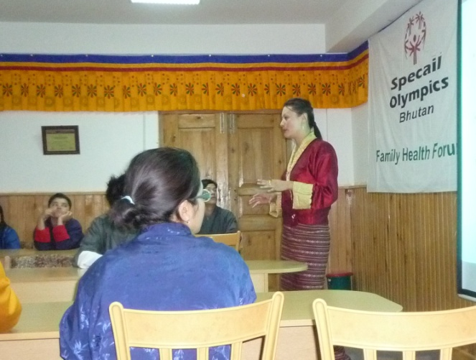 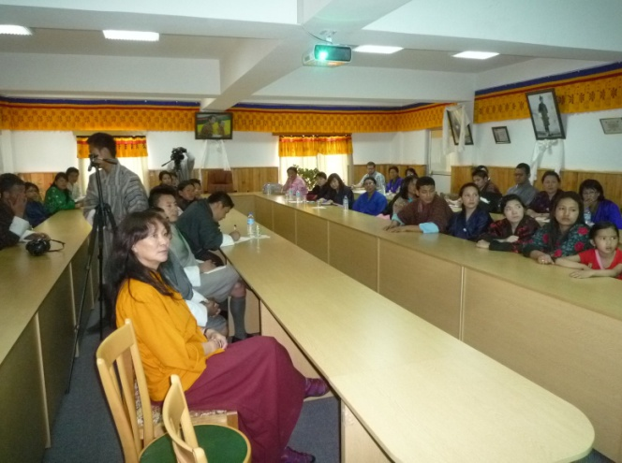 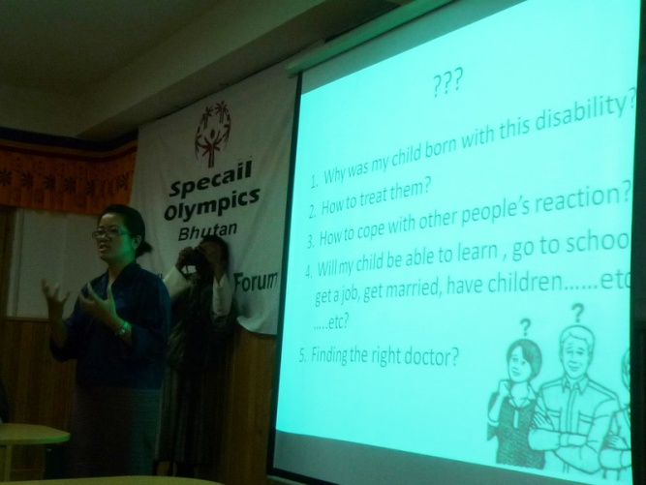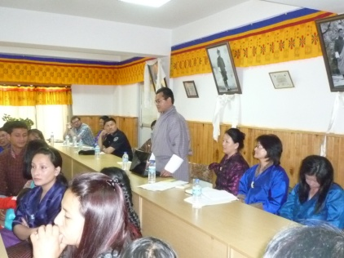

# **Eunice Kennedy Shriver Day (EKS)**

On 22nd September, 2013 the Eunice Kennedy Shriver Day (EKS) was successfully celebrated for the first time in the country by Draktsho in collaboration with Special Olympics Bhutan. More than 100 children and youth with intellectual disability participated on this day at the Jigme Dorji Wangchuck Referral Hospital. These special athletes underwent a general health check up by health professionals who volunteered to conduct this special event. Participants included special students from schools, Ability Bhutan Society and Draktsho Vocational Centre. The findings showed up that many students have eye and dental problems, where they all were referred for further medical checkup. Draktsho and Special Olympics Bhutan plan to repeat that event in 2014.

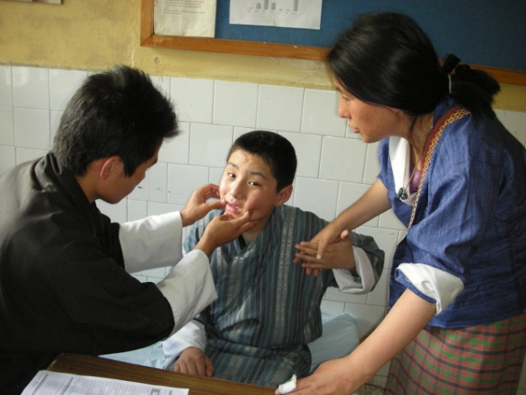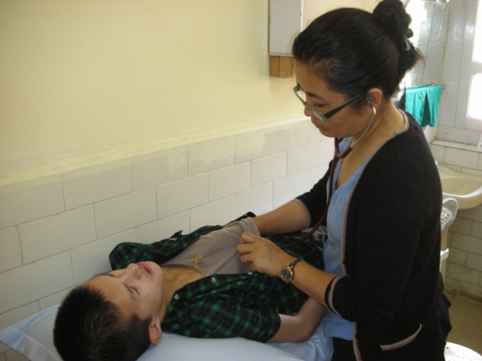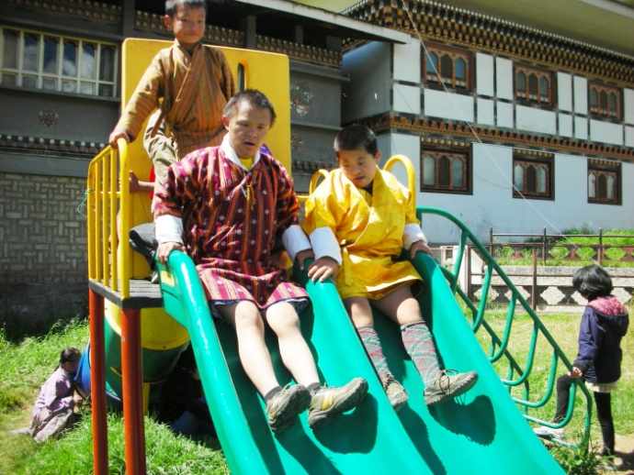 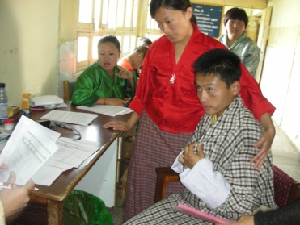

# **3rd December, the International Day of Persons with Disabilities:**

A special Olympic Meet was celebrated in December to commemorate the International Day of Persons with Disabilities. In this annual event students with special needs came from all regions to participate in Olympic types of sports to showcase their abilities. About 140 students from Draktsho, Ability Bhutan Society, Disabled People’s Association of Bhutan and Changankha Middle Secondary School came together to celebrate this day. The spectators were left with thrills and excitement all throughout the program.

Our branch at Tashigang, Draktsho East, organized an awareness walk from Sherubtse College gate to Ronghtong Vocational Centre (about 5 km). It had a small community function in the afternoon to showcase the social skills of our students and also to commemorate the celebration of the International Day for Persons with Disabilities on 3rd December.

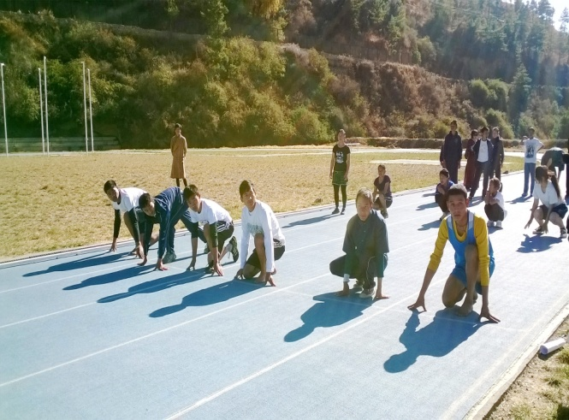 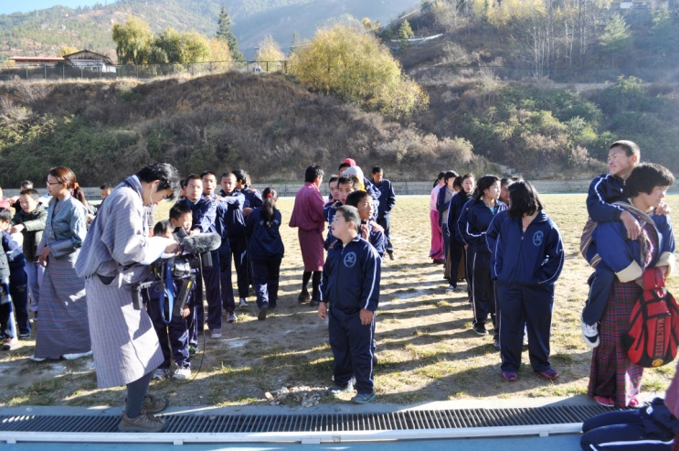 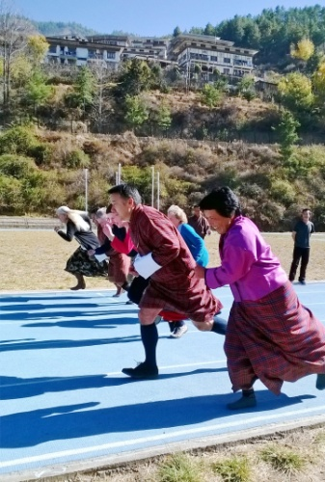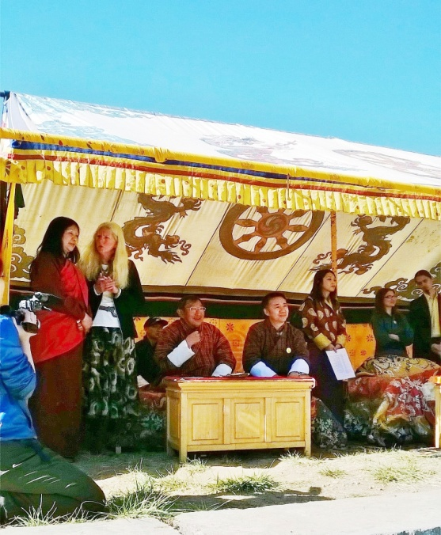 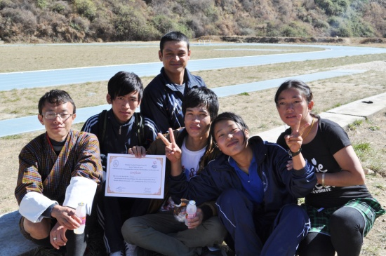 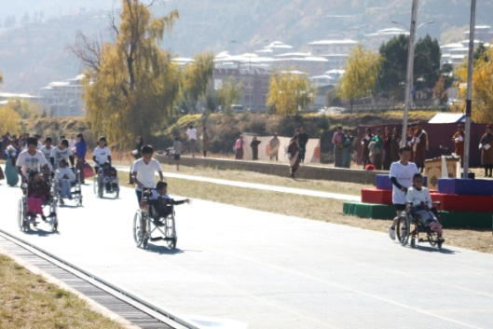

# **Ability show at the YDF hall:**

A cultural show titled ‘Ability Show’ was performed for the first time in 2013. The main objective was to showcase the abilities of youth with disabilities to the public, government, stakeholders and well wishers and to promote an understanding among the public on disability related issues as well as mobilize support for the well-being of person with disabilities. The other objectives were to raise awareness and integrate persons with disabilities with the normal society. This had been a great success as we were able to gather people from all walks of life who were overwhelmed with the confidence and performance of the students.

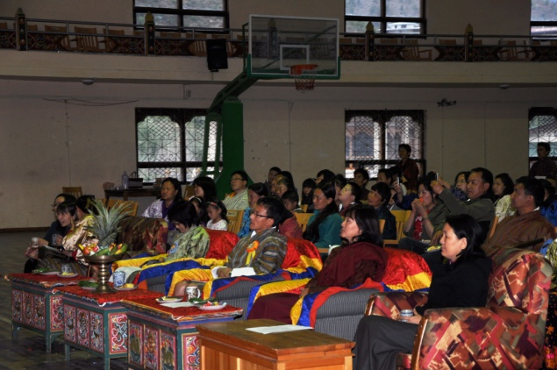 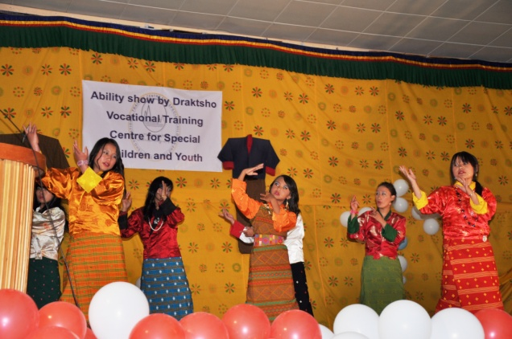

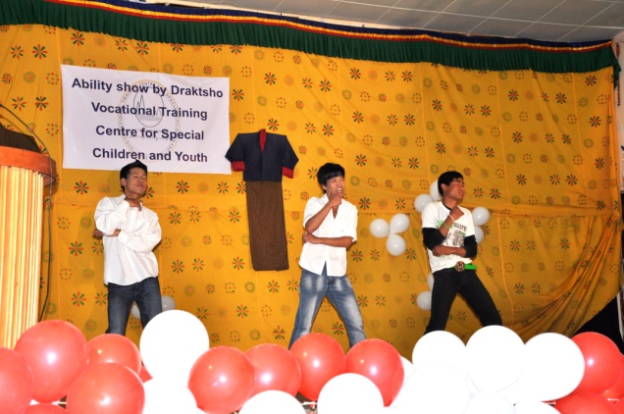 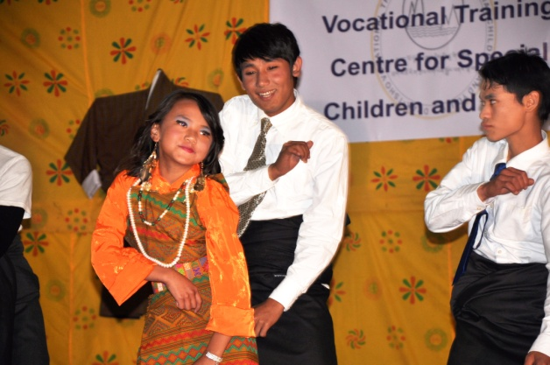

# **2nd October foundation day celebration:**

The Foundation Day has always has always remained a day of get together between staff, children and parents rather than public shows. Draktsho family desired this kind of get together to other functions as this strengthened the bond between parents, staff and students which is valuable as a family.

As envisioned in the long-term objectives of Draktsho and in its master plan, Draktsho will always endeavor to reach out its services to as many beneficiaries as possible. For the future we plan to expand our activities and programs.

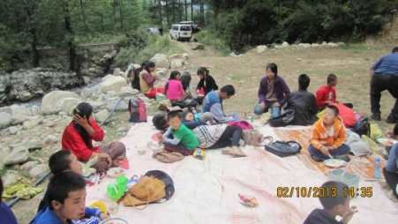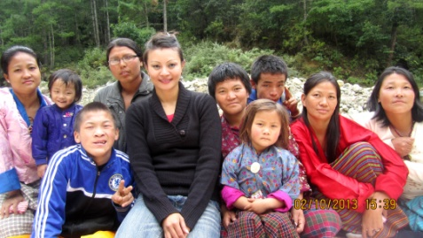 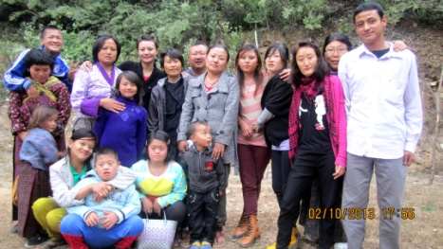

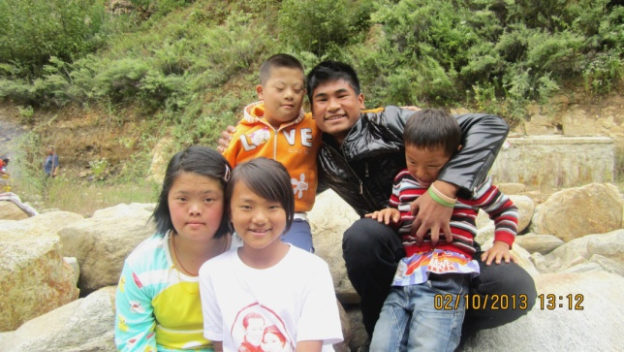 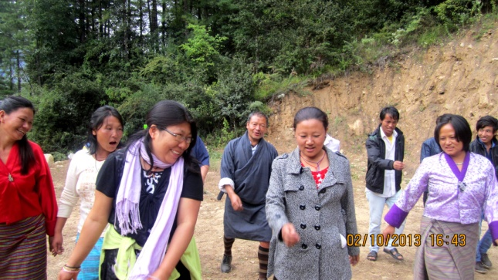

# **Draktsho East:**

The Draktsho East center in Rongthung looks back on three years of providing vocational training, life skills and functional academics to persons living with disabilities. Currently there are 60 children and youth involved in training and they are also accommodated in hostels with boarding facilities. Profound changes were brought in the lives of the children and youth so that they are now on the way to become self-reliant, which is our aim. In two years’ time from now our first batch of students will be confidently participating in the open job market or some may engage in the community activities without any discrimination. Soon the center will be having it’s own infrastructure equipped with disabled friendly facilities, where we can give quality services based on each individual’s functioning level and hope to cover more people living with disabilities in the east. Through social activities that we carried out in the community we tried to promote an understanding among public on disability related issues as well as mobilize support for dignity, rights and well-being of person with disabilities. It also seeks to increase awareness of gains to be derived from the integration of person with disabilities in every aspect of political, social, economic and cultural life.

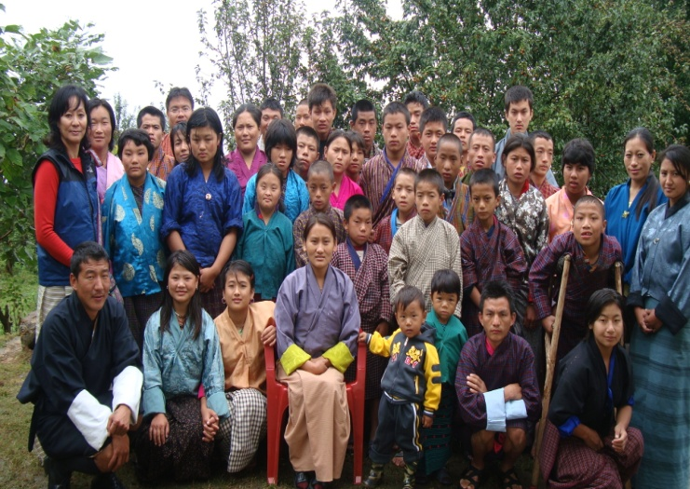 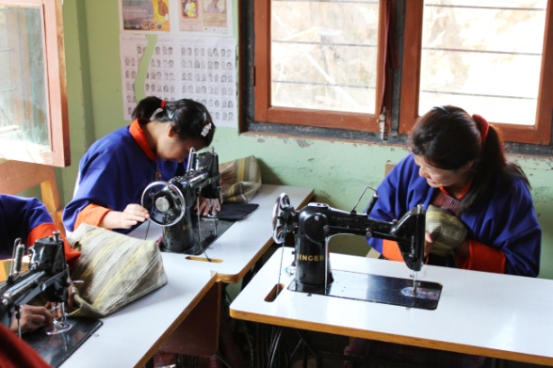

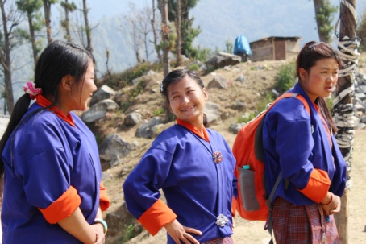 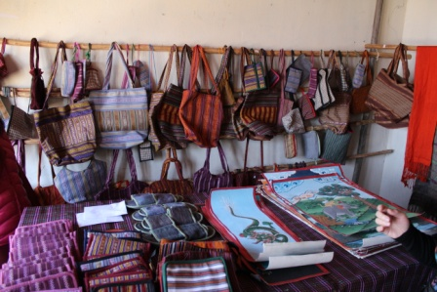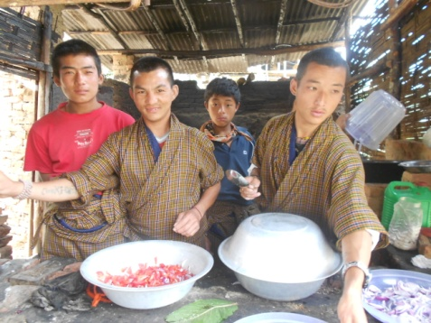

# **Immediate Future Plans:**

For 2014 the new infrastructural construction which will be accessible for persons with all types of disabilities is expected to start near Sherubtse College, Kanglung with part support from JICA, GGP, and India. As a preparation for the construction, about 5 acres of land has been acquired from the Royal Government of Bhutan in 2012. A blue print for the construction is being prepared by the Ministry of Works and Human Settlement. We also have plans to build infrastructures for Thimphu centre as we have been given land on lease from the Monastic Body, Tashichhodzong, Thimphu. As we have not got enough financial support we could not begin the constructions yet. Fund from JICA GGP, India, is for just one unit building and we need to construct at least five units to accommodate our basic services.

# **Acknowledgement:**

All our work was possible through the kindness and support of our donators. As listed below you can see a short overview of our donations:

# **Receipt and of Draktsho for the year ending 31st Dec, 2013**

|  |  |  |
| --- | --- | --- |
| Particulars | Receipt | Payment |
| Opening Balance | 10,29,240.83 |  |
| Local donation | 37,32,994.00 |  |
| Foreign Donation | 23,21,989.77 |  |
|  |  |  |
| Payment |  |  |
| Remuneration |  | 2,65,405.00 |
| Cleaning materials |  | 1,280.00 |
| Rent |  | 1,26,000.00 |
| Electricity |  | 86,000.00 |
| Stationaries |  | 35,443.00 |
| Repair and maintenance |  | 1,67,755.00 |
| Fuel |  | 88,311.53 |
| Advertisement |  | 600.00 |
| Salary |  | 23,92,861.75 |
| DSA |  | 84,501.85 |
| TDS |  | 1,70,860.60 |
| RICBL |  | 1,33,723.60 |
| Raw materials |  | 4,25,806.00 |
| Mess |  | 5,86,886.90 |
| Bhutan Telecom ltd |  | 65,289.80 |
| City water |  | 95,000.00 |
| Equipment’s |  | 51,405.00 |
| Service charges |  | 1,01,844.66 |
| Misc. Expenses |  | 7,42,114.00 |
|  | **70,84,224.60** | **56,21,088.69** |
| **Closing balance** |  | **14,63,135.91** |

|  |  |  |  |  |
| --- | --- | --- | --- | --- |
| **Donation report of Draktsho for the year ending 31st December 2013** | | | | |
| **Si. No** | **Donor,s Name** | **Currency** | **Exchange Rate** | **Amount in Ngultrum** |
| **1** | Local grands | Nu |  | 6,18,811.00 |
| **2** | MOE |  |  | 585,000.00 |
| **3** | CSO |  |  | 415,000.00 |
| **4** | Tourist |  |  | 235,481.00 |
| **5** | Ashi Beda Dorji |  |  | 50,000.00 |
| **6** | Jahanshin | USD 100 | 53.20 | 5,320.00 |
| **7** | Singapore Bhutan Foundation |  |  | 55,000.00 |
| **8** | Foundation Adenium | [USD 15980.79](mailto:15980.79@57) | 57.41 | 917,170.00 |
| **9** | Naha Hachiya NHK | Nu |  | 15,000.00 |
| **10** | OKOYFIHH | EUR 5000 | 70.82 | 353,828.75 |
| **11** | VAHEMMISTORYHMEIN | EUR 10000 | 86.02 | 859,878.90 |
| **12** | Ms. Sonam Yangtsho | Nu |  | 3,000.00 |
| **13** | ROLF SUELZER | USD 1384 | 61.38 | 84,643.00 |
| **14** | Drukpa Asia | USD 1500 | 62.63 | 93,946.00 |
| **15** | White Tara | Nu |  | 100,000.00 |
| **16** | Sangay Group of Company | Nu |  | 300,000.00 |
| **17** | Sonam Wangchuk | Nu |  | 10000.00 |
|  | **Total donation received** | | | 4,083,267.65 |